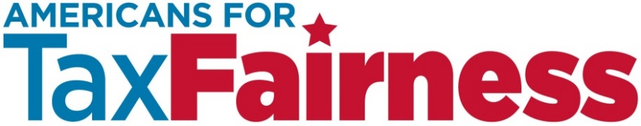

**GENERAL ELECTRIC & WALL STREET CORPORATE TAX LOOPHOLES BILL COSTS AMERICAN JOBS**

While our national leaders debate whether or not we can afford to fund vital programs like unemployment insurance, education and housing, a huge tax-break package is poised to be rubber-stamped through Congress with little consideration or debate. **That package makes it easier for big corporations like General Electric to send jobs overseas and to avoid paying billions in taxes by hiding profits in offshore tax havens.**

**Background:** Buried in a tax-loophole package, known as the “Tax Extender” bill, which gets renewed every year or two, are two tax loopholes known as the **Active Financing Exception and the CFC Look-through Rule. These two tax loopholes benefiting GE and Wall Street investment banks like Citigroup will cost us $90 billion over the next 10 years**.

* The “Tax Extender” bill contains more than 60 tax breaks that cost a total of **$450 billion to $700 billion over 10 years, depending on the final package.**  Tax breaks for corporations cost the rest of us money. Taxpayers will face more cuts to important public services and benefits because GE and banks don’t pay their fair share to support the economy.
* Many of these loopholes are **designed specifically to benefit corporations like GE and big Wall Street Banks like Citigroup;** they keep the deck stacked against average families.
* **$4 out of every $5 in tax breaks in this legislation benefits corporations**. As it stands, this bill makes tax breaks for corporations that ship jobs and profits offshore a bigger priority than investing in America, where working families are struggling.

**Timeline:** The U.S. Senate may start considering the bill in April, but the debate could go on all year. It offers an opportunity to educate voters about which side the politicians are on when it comes to corporate tax loopholes and protecting American jobs and helping the unemployed.

**WHAT WE CAN DO**

**Work together to make sure Congress DOES NOT renew the two GE and Wall Street tax loopholes. This is about fairness. If we can’t afford to extend unemployment benefits, create jobs or invest in education, roads and other public services, then we sure can’t afford more tax breaks for companies like GE that don’t even pay as much in taxes as working families.**

* **We can get the message out in the mainstream and social media that Republicans have the wrong priorities.** While they insist that we can’t afford unemployment insurance, Food Stamps and many other vital programs that average Americans depend on, they’re openly supporting these corporate tax giveaways.
* **We can build momentum for closing corporate tax loopholes organizing around this bill, Tax Day, and the November elections.** By generating and coordinating activities that elevate this message, we can send a unified message about our priorities, including jobs.