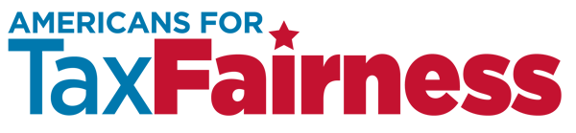

TO: Coalition Partners
FROM: Frank Clemente, Executive Director; Samantha Galing, Field and Social Media Director
DATE: April 12, 2016
RE: Tax Day digital activities that may interest your organization

If your organization is looking to do digital activities for Tax Day (April 18), this memo explains some of the resources that are available from ATF and other coalition partners. Please let us know if your organization will be using any of these materials by contacting Samantha Galing at sgaling@americansfortaxfairness.org.

All resources are being uploaded to the ATF website as they are produced.

BACKGROUND ON TAX DAY FOCUS
House Republicans are expected to unveil this spring a corporate tax “reform” plan, and they may try to move it through the Ways and Means Committee this year. It is expected to focus on international tax issues, proposing to significantly reduce the tax rate on $2.4 trillion in existing U.S. corporate offshore profits and to establish a territorial tax system with a much-lower permanent tax rate on future offshore profits. These changes would exacerbate the shifting of jobs and profits offshore. We believe the best way to fight this proposal is to highlight that corporations owe $700 billion on the $2.4 trillion in offshore profits and to demand that they Pay What They Owe.

PROPOSED ACTIVITIES

Coordinated Twitterstorm – April 18 from 2pm-3pm ET
Messages will be focused on the $700 billion owed on the $2.4 trillion in offshore profits – and what services could be financed with that money. (See Tax Day leaflet below for the latest on taxes owed by corporations and samples of tax tradeoffs.)
- Promotional tweets will be provided by Moms Rising
- Sample tweets will be provided by ATF
- Tweets will utilize #TaxDay and #CorpsPayUp
- Shareable graphics will be provided by ATF and Moms Rising (and maybe others) – see Shareables below. They will be unbranded so all organizations can use them.
- If you want to participate in the Twitterstorm contact Samantha Galing at sgaling@americansfortaxfairness.org

Social Media Shareables – April 14-18
Leading up to Tax Day (April 18), a series of graphics will be created focused on the $700 billion owed on the $2.4 trillion in offshore profits – and what services that could finance.
- Shareables could be posted from Thursday, April 14 to Monday, April 18.
- Shareables will focus on corporate tax dodgers, tax trade-offs, or other images related to the $700 billion, which are found on the Tax Day leaflet below.

Video Share About Pfizer-Viagra and Inversions – April 17 or 18
American Family Voices has taken the lead and is working with ATF and the Agenda Project to prepare a humorous video that plays on Pfizer’s Viagra pill, and how Pfizer invented this new pill called Inversion to help cope with the disease of reduced profits. The video will be available for email blasts on Sunday, April 17. A rough of the video should be available by Friday, April 15, to help you make a decision whether you are interested in it.

Email Take Action – April 18
Activists can be asked to write to the Treasury Department/IRS in support of the proposed inversion rules that it recently announced, which killed the Pfizer-Allergan inversion. Before making its inversion rules final, Treasury is seeking comments for 90 days (until July 7) about two proposed rules that make it much more difficult for a company to get tax breaks if it merges with a smaller foreign company in order to change its legal address to a tax haven (known as an inversion). Corporate America is expected to mobilize and submit a significant number of comments against the rules. (Last year, a federal judge overturned a Treasury/IRS rule in part because virtually all the comments that were submitted were from corporations against the rule.) It is important that our side weigh in supporting these rules. ATF and Daily Kos are developing a process to make it easier for groups to get their online activists to submit comments. The Pfizer inversion video will urge people to submit comments to Treasury. This action can begin on Tax Day, but ATF will also widely promote it over the next three months.

MESSAGES
- Offshore corporate tax dodgers: pay what you owe! American corporations owe $700 billion in U.S. taxes on $2.4 trillion in profits they have stashed offshore.
- We’re paying taxes today! Corporations should pay the $700 billion they owe in taxes!
- Individuals must pay what they owe on Tax Day. Corporations should too. Congress needs to close the tax loophole that lets big corporations dodge paying what they owe on offshore profits.
- If American corporations paid the U.S. taxes they owe on their offshore profits, we could create millions of good-paying jobs here at home by improving schools, making college affordable, rebuilding crumbling roads and bridges, building a green energy economy, and researching new medical cures.

A more designed version of this leaflet will be available here Thursday, April 14.

TAX DAY 2016

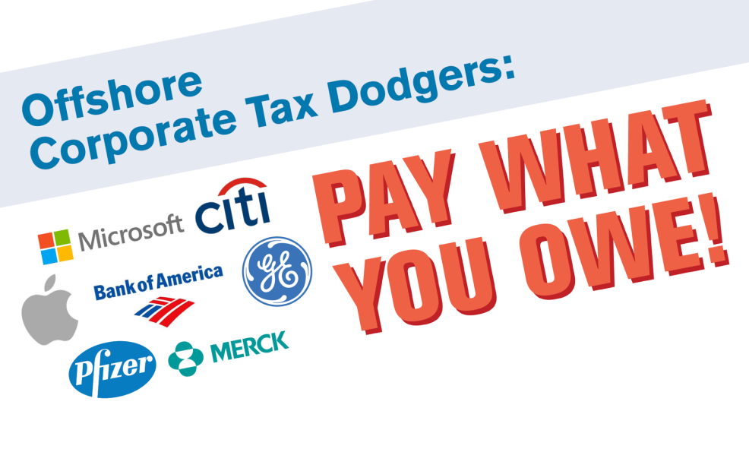

American corporations owe $700 billion in U.S. taxes on $2.4 trillion in profits they have stashed offshore.

Unlike individuals who must pay what they owe every April 15, a tax loophole lets big corporations dodge paying their tax bill indefinitely on these offshore profits.

Some corporations owe billions in U.S. taxes on their offshore profits:
Apple: $61 billion Pfizer: $35 billion Microsoft $34 billion
Citigroup: $13 billion Amgen: $11 billion Bank of America: $5 billion

Some examples of what America could do with $700 billion:
- $470 billion: Double federal highway and mass transit spending each of the next seven years.
- $75 billion: Provide high-quality preschool for all low- and moderate-income four-year-olds for 10 years.
- $61 billion: Provide two years of free tuition at community college over 10 years benefitting up to 9 million students
- $67 billion: Expand the Earned Income Tax Credit to include childless workers and non-custodial parents for 10 years.
- $27 billion: Increase the National Cancer Institute’s budget by 50% for 10 years.

We need an economy that works for all of us. By closing tax loopholes for corporations that ship jobs and hide profits offshore, we can invest in America.

Sources: Citizens for Tax Justice, http://bit.ly/1QTJYBW and Americans for Tax Fairness, http://bit.ly/25pdVkK
OFFSHORE CORPORATE TAX DODGERS PAY WHAT YOU OWE!

American corporations owe $700 billion in U.S. taxes on $2.4 trillion in profits they have stashed offshore. Unlike individuals who must pay what they owe every April 15, a tax loophole lets big corporations dodge paying their tax bill indefinitely on these offshore profits.

American corporations owe U.S. taxes on all their worldwide profits. Thanks to a loophole called “deferral,” however, they can indefinitely avoid paying their tax bill on earnings kept offshore. That special break has been a powerful incentive for companies to keep profits overseas, and to use accounting maneuvers to shift domestic ones there as well.

Though not all companies reveal how much in profits they hold offshore, Citizens for Tax Justice (CTJ) has estimated, based on an analysis of corporate financial filings, the total for all American corporations is roughly $2.4 trillion. Many corporations report how much money they’ve set aside to pay the U.S. taxes that would be due if they ever brought their money home. From these figures and other analysis, CTJ has determined American corporations owe some $700 billion in unpaid U.S. taxes on their offshore profits.

Some examples of what America could do with $700 BILLION:

- $470 billion: Double federal highway and mass transit spending each of the next seven years.
The Congressional Budget Office estimates that expenditures from the Highway Trust Fund—to pay for both highway and transit repairs and maintenance—will be $336 billion and $77 billion, respectively, between 2017 and 2023, and the deficit for the two funds combined will be $57 billion.

- $75 billion: Provide high-quality preschool for all low- and moderate-income four-year-olds for 10 years.
President Obama has promoted this Preschool for All initiative as part of a broader Early Learning program.

- $61 billion: Provide two years of free tuition at community college over 10 years benefitting up to 9 million students.
Called “America's College Promise,” this initiative has been part of President Obama’s budget proposals of the past few years. To qualify, students must attend college at least half-time, be working toward a degree and maintain good grades.

- $67 billion: Expand the Earned Income Tax Credit to include childless workers and non-custodial parents for 10 years.
Refundable tax credits available to working parents have turned the tax code into one of our nation’s most effective poverty fighters. But poor childless workers have been shut out of the system. President Obama has proposed extending the Earned Income Tax Credit to include workers without kids.

- $27 billion: Increase the National Cancer Institute’s budget by 50% for 10 years. Citing research breakthroughs just within reach, the National Cancer Institute has requested a budget of $5.5 billion for next year, or $2.7 billion if increased 50%.

