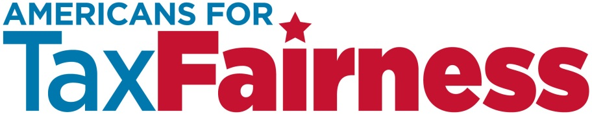

**TRUMP’S INFRASTRUCTURE PLAN TALKING POINTS**

**January, 2017**

**Background on Donald Trump’s Infrastructure**

* [Trump’s proposed plan](http://peternavarro.com/sitebuildercontent/sitebuilderfiles/infrastructurereport.pdf) for infrastructure investments dramatically differs from the standard process for financing the building and repair of our nation’s highways, water systems, and other community resources. Typically, state and local governments design, build and maintain such projects. They are paid for with a combination of state and federal grants and by borrowing money through low-interest municipal bonds.
* Trump’s plan, in contrast, encourages state and local governments to turn over control of infrastructure projects to private investors. Their investments would be heavily subsidized by taxpayers. For every dollar an investor puts into a project, they will receive a tax credit for 82 cents—an enormous subsidy from the federal government to elite Wall Street investors.
* In addition to the infrastructure projects being publicly-subsidized, governments would allow investors to raise revenues through tolls and other user fees. Building these projects would be heavily subsidized by our tax dollars, and then we would have to pay again to use them.
* The Trump plan is known as equity financing. It is a much costlier way to build infrastructure than borrowing money through the municipal bond market. Equity investors demand a much higher rate of return than municipal bond investors, as much as 300% to 500%. To ensure such high returns, the investors must charge significantly higher tolls and fees.
* Trump’s plan will not result in greater infrastructure investment or employment. In other words, the presence of tax credits will not be enough to move a stalled project forward. Instead, it may change how a project that was already slated for completion is financed— helping Wall Street and hurting taxpayers.

For more details on Trump’s infrastructure plan see these resources:

[Center for American Progress](https://www.americanprogress.org/issues/economy/reports/2016/12/01/293948/how-donald-trumps-infrastructure-plan-fails-america/)

[Center on Budget and Policy Priorities](http://www.cbpp.org/research/federal-budget/trump-infrastructure-plan-far-less-than-the-claimed-1-trillion-in-new)

[Institute on Taxation and Economic Policy](http://www.itep.org/pdf/trumpinfrastructure1116.pdf)

**Talking Points on Trump’s Infrastructure Plan**

* **Trump’s infrastructure plan is a massive tax giveaway to Wall Street investors. It is not a serious plan to repair our crumbling infrastructure.** Trump wants to give big tax breaks to Wall Street investors to encourage them to build infrastructure projects like roads and bridges that generate a steady stream of toll or other user-fee revenue. It would be less expensive for all taxpayers if corporations and the wealthy were made to pay their fair share of taxes, with the revenue used to pay for direct investment in new roads, bridges and water systems.
* **Under Trump’s plan, Americans will turn over control of public roads and bridges to private interests. They will charge expensive tolls and user fees to earn big profits for Wall Street investors, hurting the pocketbooks of average taxpayers.** Publicly-financed highways or water systems are less expensive because governments don’t charge to make a big profit. The cost is based on a project’s expenses, including the interest on low-cost municipal bonds.
* **Trump’s plan is not the change voters demanded. Instead, it’s more of the same special-interest deal making in Washington**. We want an economy that works for everyone, not just the people at the top. But Trump’s infrastructure plan benefits the wealthy and well-connected at the expense of the rest of us.
* **Trump said he would end the rigged system, but his infrastructure plan rigs it even more.** Handing our tax dollars to private investors so they can make big profits building public roads and bridges is the very definition of a rigged system.
* **Trump’s plan will not result in more infrastructure being built. It just subsidizes projects that will be built anyway**. Trump’s plan will not attract money for new projects, it simply changes how existing projects will be financed. Investors will line up for their tax subsidies, knowing a good deal when they see one, wasting tax revenues that could be used to build other needed projects.
* **Projects built by private investors are not likely be the ones our communities most need.**  Lucrative projects, such as toll roads in wealthy urban and suburban areas, will get priority under the Trump plan. Projects on which it’s harder to turn a profit—such as upgraded storm sewers—will have few takers. They will not be profitable for Wall Street fat cats. The needs of high-poverty urban areas, small towns and rural areas will be sacrificed to the big payoffs available in affluent metropolitan areas.
* **Instead of squeezing working families with high tolls and fees, wealthy corporations need to pay their fair share of taxes to finance infrastructure projects.**
* State and local governments have no trouble selling low-interest municipal bonds to investors to finance infrastructure projects. But states can only borrow so much. In the end, they need substantial grant dollars from the federal government to truly address outstanding needs
* [We need to spend $3.6 trillion](http://www.infrastructurereportcard.org/) to get all our national infrastructure resources up to snuff, according to America’s civil engineers. A good place to start paying for it is by collecting the $700 billion America’s multinational corporations owe in U.S. taxes on the [$2.5 trillion in profits they have stashed offshore](http://ctj.org/ctjreports/2016/10/offshore_shell_games_2016.php#.WDRxTbQ5zNo).