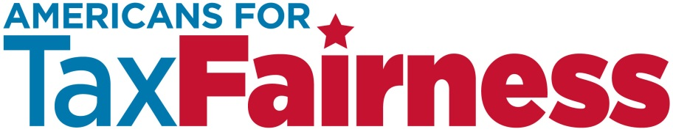

TALKING POINTS ON DONALD TRUMP’S TAX PLAN

April 2017

* **Donald Trump’s tax plan is a huge giveaway to the rich and big corporations. If President Trump is on our side, he should make the wealthy and big corporations pay their fair share of taxes so that the economy works for all of us, not just for the wealthy few.**
* Under Trump’s tax plan, millionaires and billionaires like himself get a tax cut of $1 million every year. Someone making $50,000 gets a tax cut of just $1 a day.
* **The American people have said loud and clear they want to end the rigged system in Washington. Unfortunately, Donald Trump’s tax plan rewards the powerful and well-connected.**
* Trump’s tax plan is filled with giant loopholes that benefit lobbyists and special-interests and hurt America’s families. Americans want to change business as usual, not give more tax breaks to the wealthy and well-connected. They want a government that works for them, not for special interests.
* Trump’s plan cuts the corporate tax rate by 60%. They need to pay more, not less.
* Trump wants to let Wall Street hedge fund managers, wealthy realtors and high-priced lawyers pay a tax rate of just 15%— that’s less than most middle-class families pay.

* **Trump’s tax plan doesn’t end the tax breaks that encourage corporations to send our jobs and profits offshore. We need to close that tax loophole now!**
* Corporations should pay the $750 billion in taxes they owe on their $2.6 trillion in profits stashed offshore. But Donald Trump wants to give them a huge tax discount on those profits—charging them just 10%, not the 35% they owe. You pay the taxes you owe; big corporations should do the same.
* **Donald Trump’s tax giveaways to the rich and big corporations will be paid for by the rest of us. He plans to pay for them by slashing the services and benefits that protect our families and communities.**
* Look at what Trump proposed for health care. His plan slashes Medicaid and forces 24 million people to lose health care—all to give $600 billion in tax breaks to the rich and corporations.
* **Trump’s tax giveaways to the rich and corporations will not grow the economy and create jobs. More tax breaks will simply increase their wealth and profits. Cutting corporate taxes lines the pockets of CEOs and Wall Street banks, but doesn’t help Main Street.**
* Tax breaks for corporations and the wealthy provide little bang for the buck. A one dollar cut in the corporate income tax generates just 32 cents of economic activity. That same dollar invested in rebuilding infrastructure generates four times as much.
* Instead of new giveaways to those at the top, we should invest in infrastructure, education and health care. That will create a lot more good-paying jobs for working people and protect our families.
* **Donald Trump’s tax plan will give him and his family a huge windfall that the rest of us will pay for.** Trump’s plan gives hedge fund managers and real estate tycoons like himself a huge tax cut on their businesses—cutting the tax rate they pay from just 40% to 15%. That’s far less than many middle-class families pay. Trump repeals the estate tax, which will let his children inherit billions of dollars tax free when he dies.
* **What do we want from tax reform?**
* We want the rich and corporations to pay their fair share of taxes.
* We want to end tax breaks that encourage corporations to shift jobs and profits offshore.
* We want to end the rigged tax system in Washington that rewards wealthy campaign contributors with huge handouts at the expense of average taxpayers.
* We want to make big corporations and the rich pay their fair share, so that we can invest in our communities, in education, in roads and bridges. We want to create good paying jobs, so that our economy works for all of us and not just the wealthy few.