ATF-HCAN REPORT DIGITAL TOOLKIT CONTENTS
- Shareable images
- FB posts and tweets
- Email and petition copy

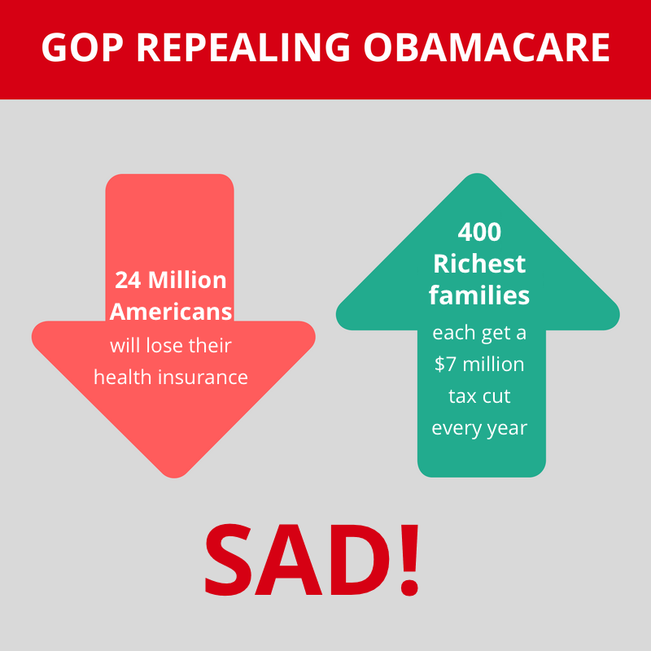
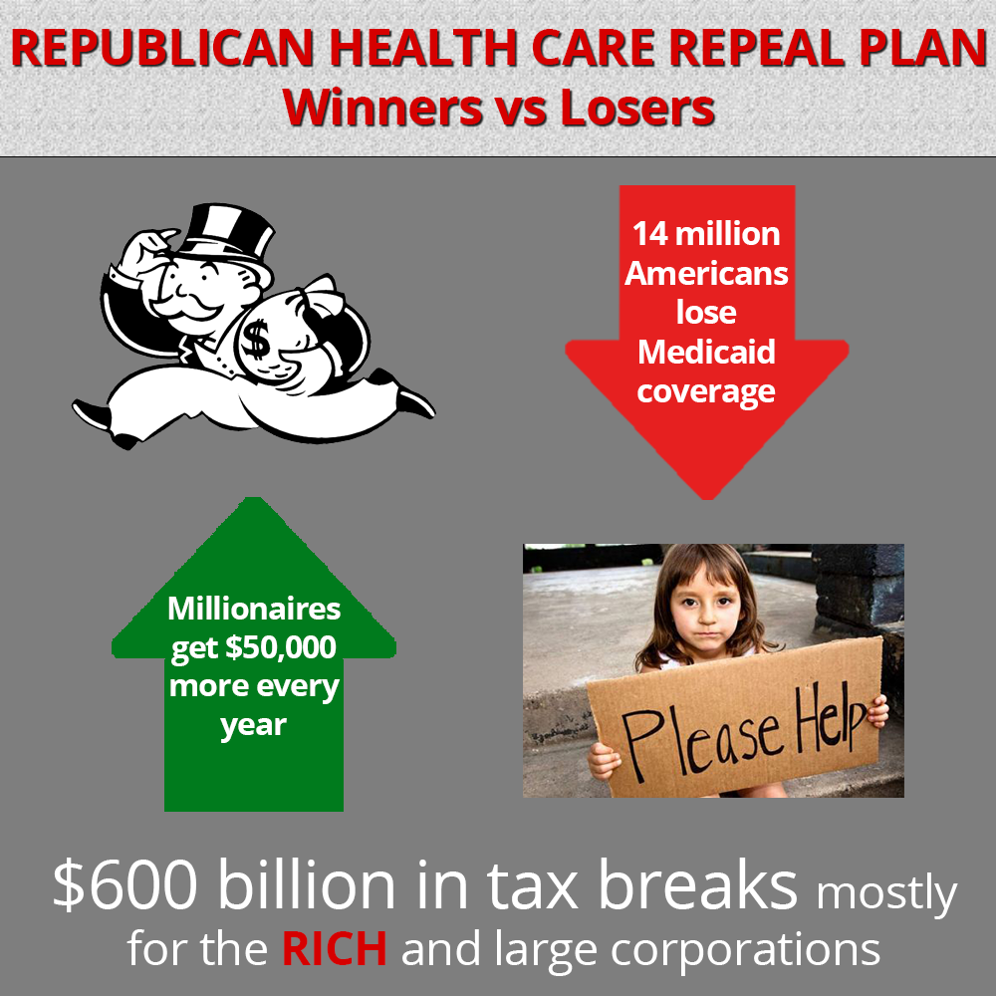
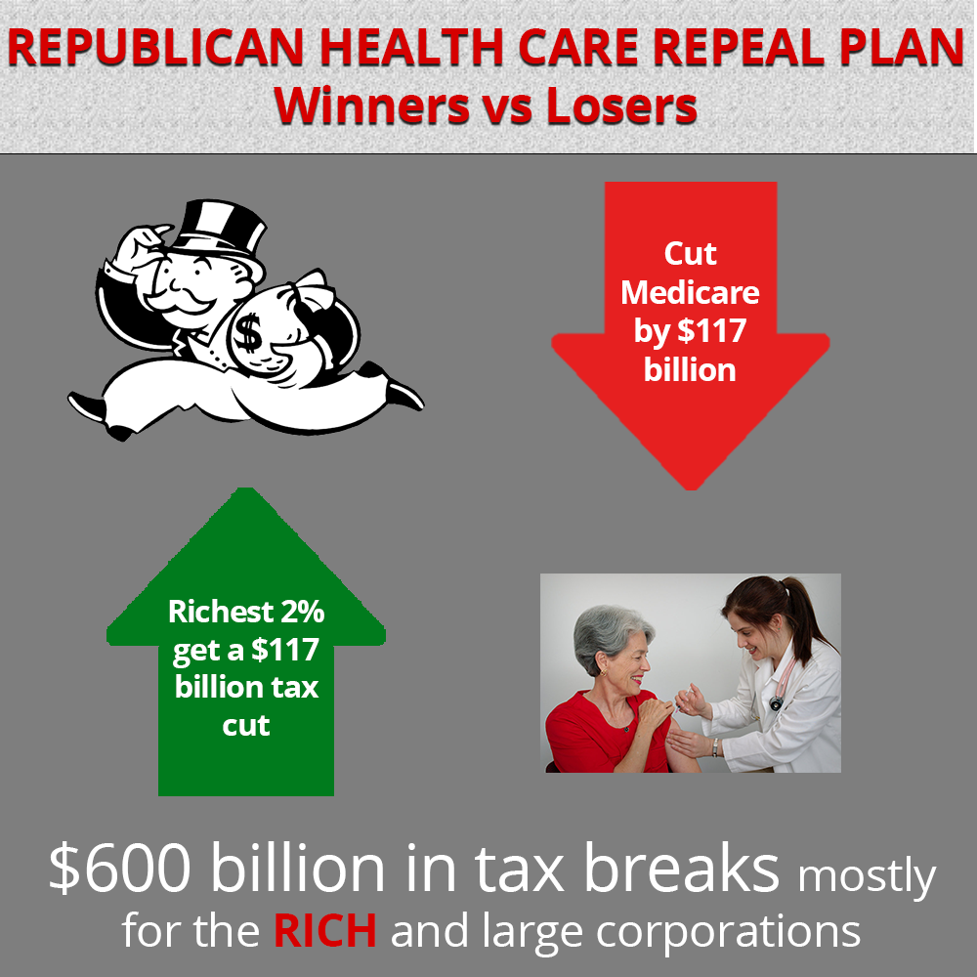
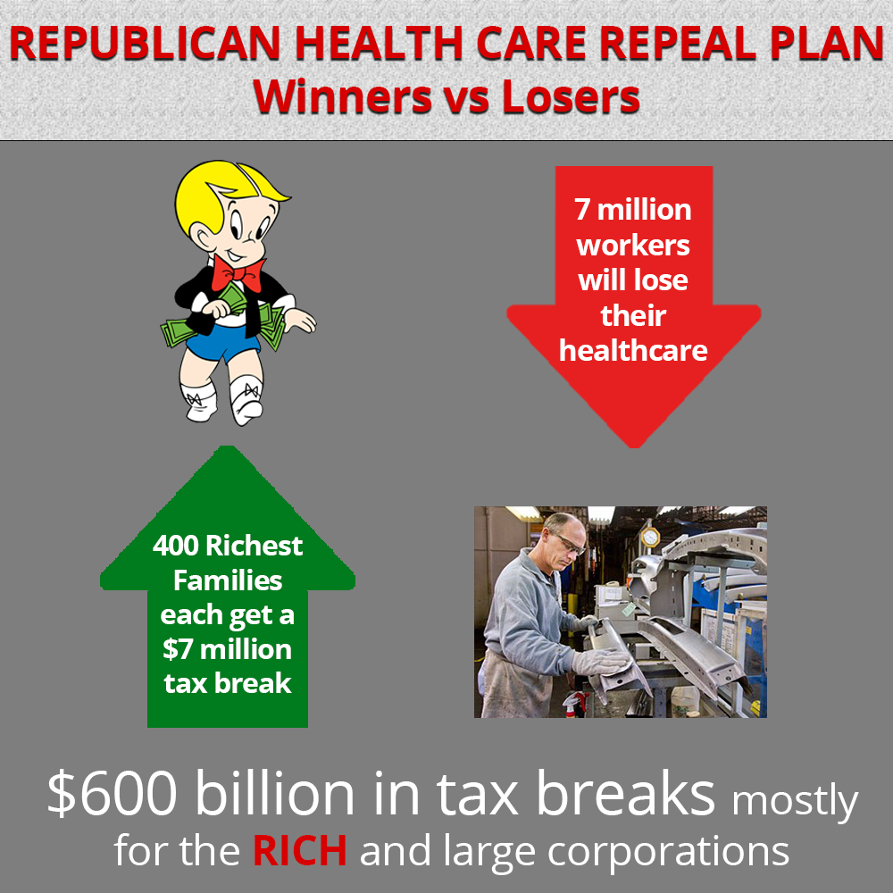

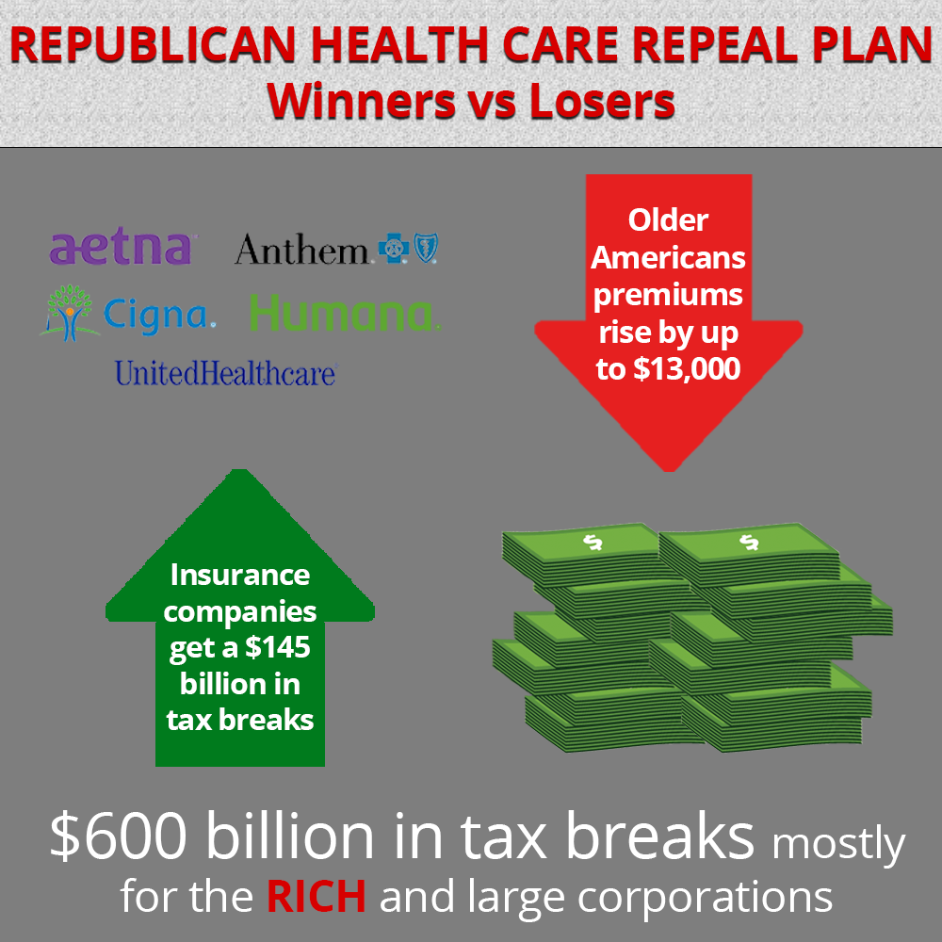

SAMPLE FACEBOOK POSTS

- The Republican health care repeal plan is a disaster for America. It gives $600 billion in tax breaks, mostly to the rich and corporations, paid for by taking health care away from 24 million Americans. Read more in the new report from @Americans for Tax Fairness and @Health Care for America Now here: http://bit.ly/2or2Yh3

- Under the Republican health care repeal plan 14 million low-income kids and seniors will lose their Medicaid coverage. Why? Because Donald Trump thinks that millionaires like himself need a $50,000 a year tax break. Learn more in a new report from @Americans for Tax Fairness and @Health Care for America Now here: http://bit.ly/2or2Yh3

- During the Trumpcare fight, Republicans changed their health care bill at the last minute to give the rich retroactive tax cuts. This was on top of the already $7 million a year tax break their plan gave away to the 400 richest families in America. Wouldn't it be nice to get retroactive health care? Find out who the real winners and losers of the Republican healthcare repeal plan are in the new report by @Americans for Tax Fairness and @Health Care for America Now here: http://bit.ly/2or2Yh3

- Drug companies making record profits get a $25 billion tax break under the Republican health care repeal plan. The kicker? The American people will still have no protection from huge drug price increases. Learn more from @Americans for Tax Fairness and @Health Care for America Now here: http://bit.ly/2or2Yh3

- Older Americans are already struggling to save for retirement. So, what do Republicans propose to fix this? Give a $145 billion tax break to the insurance companies. Seniors on the other hand get to pay up to $13,000 more a year in premiums. Learn more in a new report from @Americans for Tax Fairness and @Health Care for America Now here: http://bit.ly/2or2Yh3

SAMPLE TWEETS

- #GOPHealthCare plan is a $600 billion tax break for wealthy & corps. but 24 million lose health coverage. http://bit.ly/2or2Yh3

- Number of uninsured in US has fallen to lowest level bc of #ACA. #GOPHealthCare repeal plan will cut coverage & raise costs. http://bit.ly/2or2Yh3

- #GOPHealthCare repeal plan includes tax breaks for insurance companies at expense of seniors’ healthcare. http://bit.ly/2or2Yh3

- New report highlights how #Trumpcare cuts Medicare in a big way. All so richest 2% get a $117 tax break. http://bit.ly/2or2Yh3

- Health insurance companies made record profits last year. They don't need $145 billion tax break. #Trumpcare http://bit.ly/2or2Yh3

EMAIL AND PETITION

NAME,
President Trump and House Republicans have proposed a disastrous plan to dismantle the Affordable Care Act (ACA). It will take health coverage away from 24 million of Americans while handing $600 billion in tax breaks mostly to the wealthiest Americans and the biggest health insurance and prescription drug corporations.¹

Quite simply, ACA repeal means tax cuts for the rich and health care cuts for everyone else.

The GOP’s plan provides the first big tax breaks among many that they hope to give the wealthy and Washington special interests this year.

Under the House Republican plan, the richest 400 U.S. families would each get a $7 million annual tax break, while working families and seniors would be left to fend for themselves with inadequate tax credits to buy health insurance. The government will no longer guarantee they can afford coverage.

Sign the petition today demanding Congress reject any ACA replacement that hurts working families, and that hands $600 billion in tax breaks to the rich and big corporations.

One of the major achievements of the Affordable Care Act is that it has decreased economic inequality even as it improves the nation’s health. It’s done this by taxing the wealthy and insurance and prescription drug corporations, and using those tax dollars to help 20 million low- and middle-income Americans afford health care.

Now, instead of asking the richest Americans and most profitable corporations to pay their fair share, the Republican plan hurts low- and moderate-income families and seniors by slashing financial support to buy health insurance, drastically cutting Medicaid, and hurting the long-term funding of Medicare.

We must stop this massive shift of wealth away from working families and seniors up to the wealthy and profitable corporations.

Sign the petition today! Reject the Republican plan that gives a $600 billion tax break to the rich and big corporations, while gutting health coverage for millions of Americans.

Together, let’s fight for a tax system and a health care system that works for all of us, not just the wealthy few.
Thank you,
Frank Clemente
Executive Director
Americans for Tax Fairness
[1] Americans for Tax Fairness and Health Care for America NOW!, “REPUBLICAN HEALTH CARE REPEAL PLAN: Tax Cuts for the Rich, Health Care Cuts for Everyone Else.” (April 2017)

Petition
The health care repeal plan put forward by President Trump and House Republicans means tax cuts for the rich and health care cuts for everyone else.
The GOP’s plan for replacing the Affordable Care Act is the first of many big tax breaks they want to give the wealthy and well-connected special interests. It will hand $600 billion in tax breaks to the wealthiest Americans and the biggest health insurance and prescription drug corporations.
Twenty-four million Americans will lose health coverage under the Republican health care repeal plan because it slashes financial assistance to help people buy health insurance, drastically cuts Medicaid, and hurts the long-term funding of Medicare.
Sign the petition today demanding that Congress reject the Republican health care repeal plan. It hurts working- and middle-class families while handing $600 billion in tax breaks to the rich and big corporations.
Petition Text:
To: All Members of Congress
From: Craig Johnson
Under the Republican health care repeal plan the rich will get big tax cuts everyone else will get big health care cuts. This legislation gives $600 billion in tax breaks mostly to the wealthy and big health care corporations at the expense of every day Americans. The richest 400 U.S. families would each get a $7 million annual tax break, while working families and seniors will be left to fend for themselves. That’s because the GOP health care repeal plan would slash financial support to buy health insurance, drastically cut Medicaid, and hurt the long-term funding of Medicare. I urge you to reject any repeal of the Affordable Care Act that hurts working families while handing billions of dollars in tax breaks to the rich and big corporations.

